**UNIT 2: What’s this?**

**EXERCISES**

**Exercise 1: Copy the words.**

**desk desk**

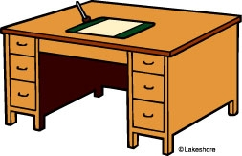

**chair**

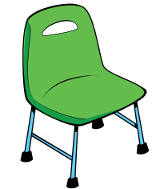

**crayon**



**pencil**

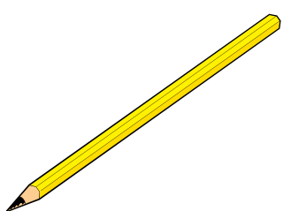

**notebook**

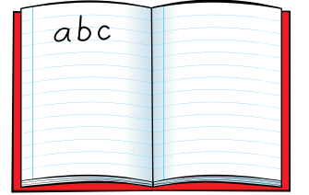

**egg**

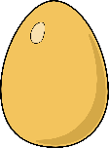

**elephant**



**fish**

**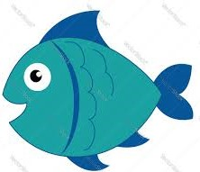**

**farm**

**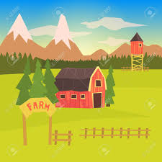**

**five**

****

**six**

**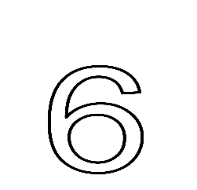**

**Exercise 2: Look and write the missing letters.**

|  |  |  |  |  |
| --- | --- | --- | --- | --- |
| Káº¿t quáº£ hÃ¬nh áº£nh cho desk clipart |  |  |  |  |
| d \_ sk | c \_ air | cray \_ n | penci \_ | noteb\_ \_ k |

**Exercise 3: Look at the pictures and write.**

|  |  |
| --- | --- |
| Káº¿t quáº£ hÃ¬nh áº£nh cho desk clipart   1. What’s this?     ***It’s a desk.*** | 1. What’s this?   *It’s a ……………………………* **.** |
| 1. What’s this?   *It’s a ………………………..* ***.*** | 1. What’s this?   *It’s a …………………………* ***.*** |
| 1. What’s this?   *It’s ……………………………* ***.*** | Káº¿t quáº£ hÃ¬nh áº£nh cho bat  clipart   1. What’s this?   *…………………………………………* ***.*** |

**Exercise 4: Look and tick (✓) or cross (X).**

  

**X**

**✓**

a) It’s a desk. b) It’s a pencil. c) It’s a chair.

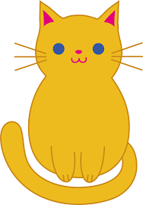  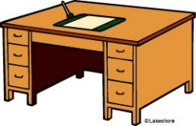

d) It’s a dog. e) It’s a crayon. f) It’s a desk.

**Exercise 5: Circle the correct answer.**

a) It’s a desk / chair. b) It’s a crayon / pencil.

 c) It’s a pencil / notebook. d) It’s acrayon / notebook.

 e) It’s a chair / desk. 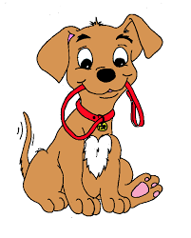 f)It’s a cat / dog.

**Exercise 6: Count and write.**

|  |  |
| --- | --- |
| Káº¿t quáº£ hÃ¬nh áº£nh cho desk clipart Káº¿t quáº£ hÃ¬nh áº£nh cho desk clipart | ***two*** desks |
| 240_F_195357855_EmOx3BQiuoFPEQoCViaPHHKZPCu4c2Ag     240_F_195357855_EmOx3BQiuoFPEQoCViaPHHKZPCu4c2Ag     240_F_195357855_EmOx3BQiuoFPEQoCViaPHHKZPCu4c2Ag     240_F_195357855_EmOx3BQiuoFPEQoCViaPHHKZPCu4c2Ag | \_\_\_\_\_\_\_ notebooks |
| pencil-coloring-page-23-pencil-coloring-page-free-printable-pencil-coloring-pages-for-free        pencil-coloring-page-23-pencil-coloring-page-free-printable-pencil-coloring-pages-for-free    pencil-coloring-page-23-pencil-coloring-page-free-printable-pencil-coloring-pages-for-free     pencil-coloring-page-23-pencil-coloring-page-free-printable-pencil-coloring-pages-for-free  pencil-coloring-page-23-pencil-coloring-page-free-printable-pencil-coloring-pages-for-free | \_\_\_\_\_\_\_\_ pencils |
| crayon-coloring-pages-wecoloringpage-crayon-coloring-pages-1010x1024 crayon-coloring-pages-wecoloringpage-crayon-coloring-pages-1010x1024 crayon-coloring-pages-wecoloringpage-crayon-coloring-pages-1010x1024 crayon-coloring-pages-wecoloringpage-crayon-coloring-pages-1010x1024 crayon-coloring-pages-wecoloringpage-crayon-coloring-pages-1010x1024 crayon-coloring-pages-wecoloringpage-crayon-coloring-pages-1010x1024 | \_\_\_\_\_\_\_\_ crayons |

**Exercise 7: Read and color**.

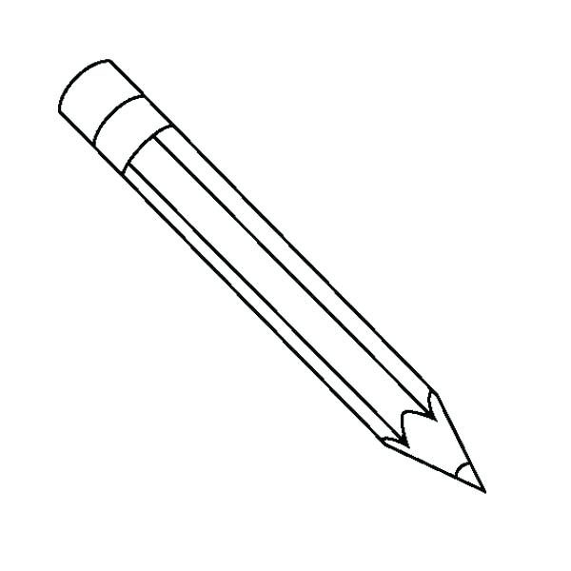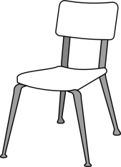



It’s a yellow pencil.

It’s a green chair.



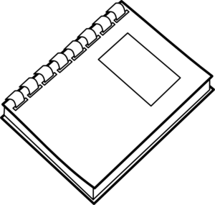

It’s a blue crayon.

It’s a red notebook.

**Exercise 8: Circle the right pictures.**

|  |  |  |  |
| --- | --- | --- | --- |
| Aa |  |  |  |
| Bb | Káº¿t quáº£ hÃ¬nh áº£nh cho duck  clipart |  |  |
| Cc |  |  |  |
| Dd | Káº¿t quáº£ hÃ¬nh áº£nh cho duck  clipart | Káº¿t quáº£ hÃ¬nh áº£nh cho egg clipart | **C:\Users\dell\Downloads\farm.jpg** |
| Ee |  |  | Káº¿t quáº£ hÃ¬nh áº£nh cho elephant clipart |